

Safety Data Sheet
FTS-DJH1

1. IDENTIFICATION
Product name | CONCRETE MASONRY UNITS
Description | CONCRETE MASONRY PRODUCTS
Product class | MASONRY
Supplier address | 30243 MILLSBORO HWY  MILLSBORO,DE. 19966
Telephone numbers
Company Phone Number | 302-934-9237
Emergency Telephone | HEALTH AND TRANSPORT:610-926-1024

2. HAZARDS IDENTIFICATION
Hazard classification | Skin Contact, Category 1  Inhalation, Category 1B
Signal word | Danger
Hazard statements | Dry sawing of precast lintel may result in release of respirable crystalline quartz. Prolonged exposure to crystalline quartz may cause delayed lung injury.
Pictograms of related hazards | 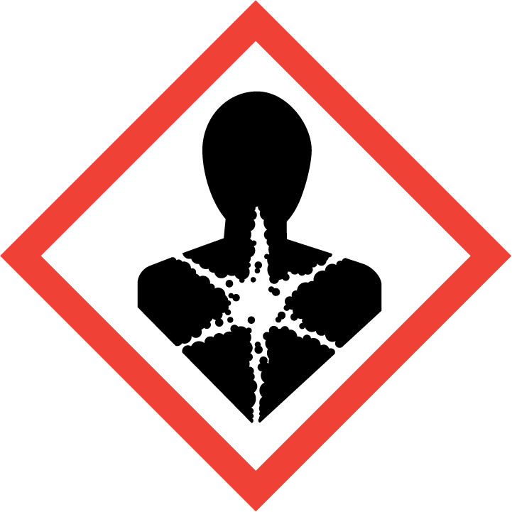
Precautionary statements
Prevention
Wear protective gloves, protective clothing, eye protection, and face protection.
Avoid breathing dust.
Wear respiratory protection.
Response
Wash contaminated clothing before reuse.
Specific treatment—see "First Aid Measures."
IF INHALED: Remove victim to fresh air and keep at rest in a position comfortable for breathing.
IF IN EYES: Rinse cautiously with water for several minutes. Remove contact lenses if present and easy to do. Continue rinsing. Immediately contact a POISON CENTER or health care provider.
If experiencing respiratory symptoms: Contact a POISON CENTER or health care provider.
Storage
NONE
Disposal
Disposal: Residue from saw cutting in accordance with local, state, and federal regulations.

3. COMPOSITION/INFORMATION ON INGREDIENTS
Chemical Name | CAS # | Weight %
Silicon Dioxide SiO | 14808-60-7 | 1–10
Non-hazardous substances | Proprietary | >90

4. FIRST-AID MEASURES
Eye contact | Flush eyes with plenty of water for at least 15 minutes, lifting lower and upper eyelids occasionally to ensure complete rinsing. Remove contact lenses if present and easy to do, then resume rinsing. Get medical attention if symptoms occur.
Skin contact | Remove contaminated clothing and wash the affected area with soap and water. Wash contaminated clothing before reuse.
Ingestion | If swallowed, DO NOT induce vomiting. Rinse mouth and get emergency medical attention. Do not give anything by mouth unless instructed to do so by a poison center or health care provider.
Inhalation | If inhaled, move victim to fresh air. Seek emergency medical attention if breathing is difficult; perform artificial respiration if breathing stops.
Note to health care provider | Allergic reaction or asthma exacerbation may occur in sulfite-sensitive individuals.

5. FIRE-FIGHTING MEASURES
Suitable extinguishing media | NOT COMBUSTIBLE
Unsuitable extinguishing media | No information available
Protective equipment and precautions for firefighters | NONE
Specific hazards | Dust
Hazardous combustion products | Silicon Dioxide SiO

6. ACCIDENTAL RELEASE MEASURES
Personal precautions | N/A
Methods for clean-up
Small spills | N/A
Large spills | N/A

7. HANDLING AND STORAGE
Advice on safe handling | Avoid dust contact with eyes, skin, . Avoid breathing dust. Wash hands thoroughly after handling.
Storage conditions | NONE
Suitable materials of construction | NONE
Unsuitable materials of construction | NONE

8. EXPOSURE CONTROLS/PERSONAL PROTECTION
Eye/face protection | Safety Glasses, face shield
Skin protection | Body-covering clothing
Respiratory protection | Observe published airborne exposure limits. NIOSH approved respirator should be used in accordance with OSHA respiratory protection requirements (29 CFR 1910.134
Engineering controls | Adequate ventilation, eye-wash station,
General hygiene considerations | NONE.

Chemical Name | OSHA PEL | ACGIH TLV
Silicon Dioxide SiO | 29 CFR 1910.1000 | TLV-TWA=0.1 mg/M
2-(Diethylamino)-ethanol (DEAE) | Click here to enter text. | Click here to enter text.
Non-hazardous substances | None established | None established

9. PHYSICAL AND CHEMICAL PROPERTIES
pH | N/A
Appearance | Odorless Solid
Odor | Orderless
Odor Threshold | N/A
Melting/freezing point | N/A
Initial boiling point/boiling range | No information available
Flash point | No information available
Evaporation rate | No information available
Flammability (solid, gas) | No information available
Upper/lower flammability or explosive limits | No information available
Vapor pressure | No information available
Vapor density | No information available
VOC content | No information available
Specific gravity | No information available
Solubility | No information available
Partition coefficient  n-octanol/water | No information available
Auto-ignition temperature | No information available
Decomposition temperature | No information available
Viscosity | No information available

10. STABILITY AND REACTIVITY
Chemical stability | N/A
Hazardous polymerization | N/A
Conditions to avoid | N/A
Incompatibilities | N/A
Hazardous decomposition products | No known non-thermal decomposition hazards.

11. TOXICOLOGICAL INFORMATION
Likely routes of exposure | Skin, eyes, ingestion
Parameter |  | Result
N/A
Parameter |  | Result

Acute symptoms and effects
Eye | Eye irritation with or without pain, burning, itching, redness, and discharge.
Skin | Skin irritation with or without pain, burning, itching, redness, and swelling.
Ingestion | Gastrointestinal distress with or without nausea, vomiting, and diarrhea.
Inhalation | Upper respiratory irritation with or without cough, watering of the eyes. Inhalation may induce or exacerbate symptoms of allergy or asthma in sulfite-sensitive individuals.
Reproductive effects | No information available
Teratogenicity | No information available
Mutagenicity | No information available
Embryotoxicity | No information available
Sensitization to product | May cause allergic reaction
Synergistic products | No information available
Carcinogenicity | Components have been identified as carcinogenic by NTP.
Chronic | No information available

12. ECOLOGICAL INFORMATION
Aquatic toxicity
Parameter |  | Result
N/A
Parameter |  | Result

Persistence | No information available
Bioaccumulative potential | No information available
Mobility | No information available

13. DISPOSAL CONSIDERATIONS
Disposal | Dispose of in accordance with federal, state, and local regulations.
RCRA status | Discarded product, as sold, would not be considered a RCRA Hazardous Waste.

14. TRANSPORT INFORMATION
US Department of Transportation (DOT)
UN Number
Proper shipping name | Not regulated
Primary hazard class/division
Secondary hazard
Packing group
Label

15. REGULATORY INFORMATION
OSHA Hazard Communication Status | Skin Corrosion, Category 1  Inhalation, Category 1B  Eye Damage, Category 1
EPA Registration Number | Not applicable
TSCA | The ingredients of this product are not listed on the Toxic Substances Control Act (TSCA) Chemical Substances Inventory.
CERCLA
EPA Hazardous Substances (40 CFR 302)
Chemical Name | Reportable Quantity (RQ)
Non-hazardous substances | None
 | Click here to enter text.

SARA Title III (Sections 302, 311, 312, and 313)
Section 302 Extremely Hazardous Substances (40 CFR 355)
Chemical Name | CAS# | RQ | TPQ
None

Section 311 and 312 Health and Physical Hazards
Immediate | Delayed | Fire | Pressure | Reactivity
Yes | Yes | No | No | No

Section 313 Toxic Chemicals (40 CFR 372)
Chemical Name | CAS Number | Percent by Weight
None

16. OTHER INFORMATION
HMIS Ratings | Health—2; Flammability—1; Reactivity—0
NFPA Ratings | Health—2; Flammability—1; Reactivity—0; Special Hazard—None
HMIS and NFPA Rating Scale | Minimal—0; Slight—1; Moderate—2; Serious—3; Severe—4
SDS Issue Date | April 22, 2015
Revision Date | Version 1

The information provided in this Safety Data Sheet is correct to the best of our knowledge, information, and belief at the date of its publication. The information given is designed only as guidance for safe handling, use, processing, storage, transportation, disposal, and release and is not to be considered a warranty or quality specification. The information relates only to the specific material designated and may not be valid for such material used in combination with any other materials or in any process, unless specified in the text

